Assignment-13.1
Task Description #1 (Refactoring – Removing Code Duplication)
• Task: Use AI to refactor a given Python script that contains
multiple repeated code blocks.Instructions:Prompt AI to identify duplicate logic and replace it with
functions or classes.Ensure the refactored code maintains the same output.Add docstrings to all functions.Sample Legacy Code:
# Legacy script with repeated logic
print("Area of Rectangle:", 5 * 10)
print("Perimeter of Rectangle:", 2 * (5 + 10))
print("Area of Rectangle:", 7 * 12)
print("Perimeter of Rectangle:", 2 * (7 + 12))
print("Area of Rectangle:", 10 * 15)
print("Perimeter of Rectangle:", 2 * (10 + 15))
• Expected Output:
o Refactored code with a reusable function and no
duplication.
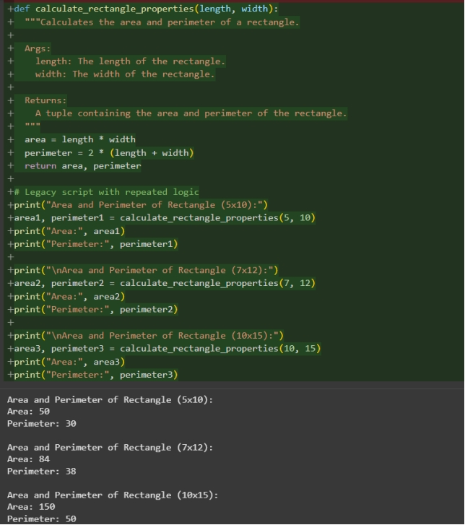

Prompt: Give Pythion code identify duplicate logic and replace it with
functions or classes.Ensure the refactored code maintains the same output.Add docstrings to all functions

Observation: I have Observed that it identifies duplicate logic and replace it with
functions or classes

Task Description #2 (Refactoring – Optimizing Loops and
Conditionals)
• Task: Use AI to analyze a Python script with nested loops and
complex conditionals.
• Instructions:AI to suggest algorithmic improvements (e.g., replace
nested loops with set lookups or comprehensions). Implement changes while keeping logic intact.Compare execution time before and after refactoring.
• Sample Legacy Code:
# Legacy inefficient code
names = ["Alice", "Bob", "Charlie", "David"]
search_names = ["Charlie", "Eve", "Bob"]
for s in search_names:
found = False
for n in names:
if s == n:
found = True
if found:
print(f"{s} is in the list")
else:
print(f"{s} is not in the list")
• Expected Output:
o Optimized code using set lookups with performance
comparison table
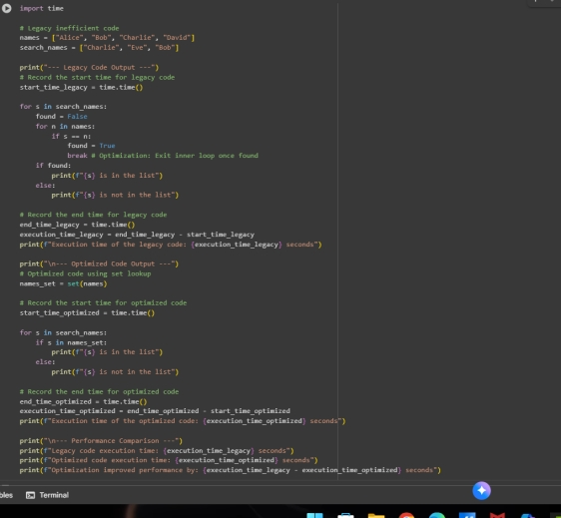

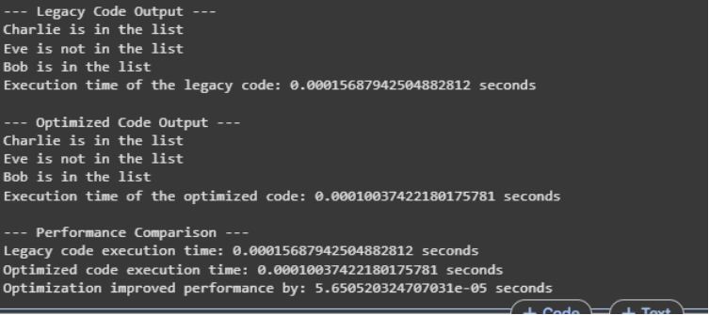
Prompt: Give Pt+ython code replace
nested loops with set lookups or comprehensions Implement changes while keeping logic intact.Compare execution time before and after refactoring. o Optimized code using set lookups with performance
comparison table
Observation: I have observed that It give comparison of both legacy and optimized codes with execution time

Task Description #3 (Refactoring – Extracting Reusable Functions)
(Refactoring – Replacing Hardcoded Values with Constants)
• Task: Use AI to identify and replace all hardcoded values in the
code with named constants.
• Instructions:Create constants at the top of the fileReplace all hardcoded occurrences in calculations with
these constants Ensure the code remains functional and is easier to
maintain.
• Sample Legacy Code:
# Legacy script with hardcoded values
print("Area of Circle:", 3.14159 * (7 ** 2))
print("Circumference of Circle:", 2 * 3.14159 * 7)
• Expected Output:
o Code with constants like PI = 3.14159 and RADIUS = 7
used in calculations.
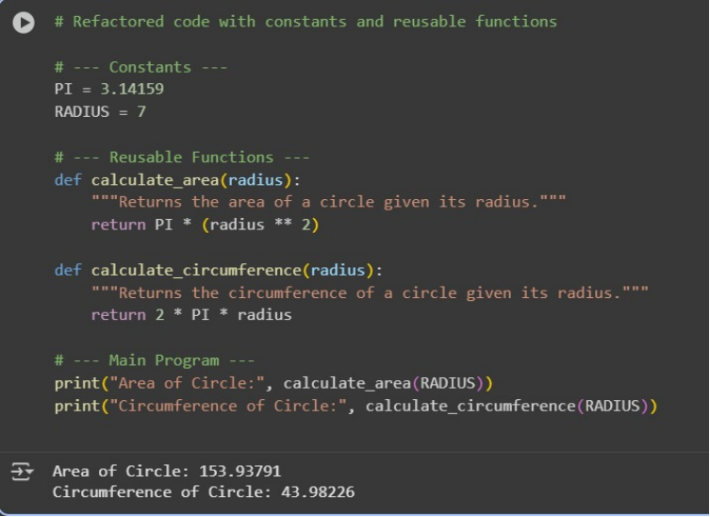

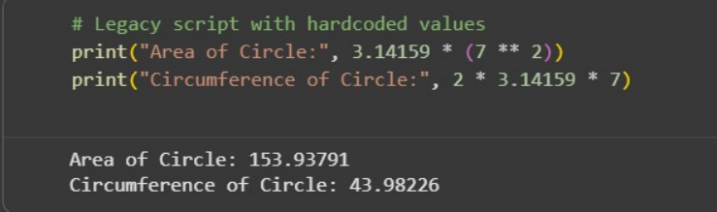
Prompt : Give Python code identify and replace all hardcoded values in the
code with named constants.Create constants at the top of the fileReplace all hardcoded occurrences in calculations with these constants Ensure the code remains functional and is easier to maintain.
Observation :
I have observed that it Create constants at the top of the fileReplace all hardcoded occurrences in calculations

